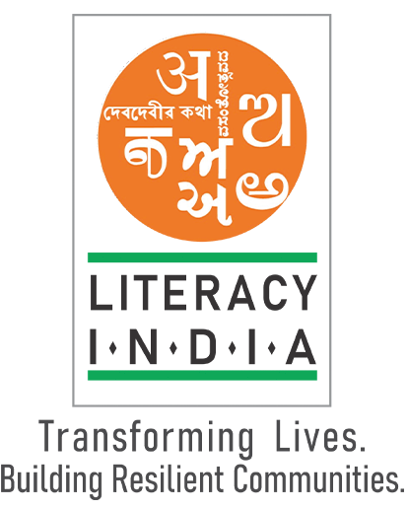

**Programs Offered**

* Robotics/Tinkering
* Computer Hardware
* Mobile Repairing
* Cooking/Hospitality
* Beauty & Weliness
* Stitching & Cutting
* Electrical Troubleshooting
* Two-Wheeler Repairing
* Mobile Journalism
* Comouter Science
* Call Center/BPO
* Logistice
* Date Digitization
* Natural Farming Market Connect
* Banking

Limited seats

Register Now

[www.literacyindia.org](http://www.literacyindia.org)

Session Starts From

January 2024

Contact no- 8588853380

Literacy India Community College (ILCC)